Setting up your environment

Programming and Fundamentals C#

Spring Semester 2021

horizontal line

# *Note: A Windows 7 or later Operating System is a requirement for this semester*

# Summary

1. Install Discord and Join Virtual Classroom
2. Install Notepad++ & Git
3. Install Git SCM
4. Install TortoiseGit
5. Install Visual Studio Community
6. Install Balsamiq
7. Register at GitHub Classroom and Setup Online and Local Repositories
8. Install IOGear USB 3.0 Docking Station Drivers

# 

# 

# 

# 

# 

# 

# Install Discord and Join Virtual Classroom

1. Download the Discord Desktop App for Windows or Mac
   1. <https://discord.com/>
2. Create an Account and login to the Desktop App or Login with a current account

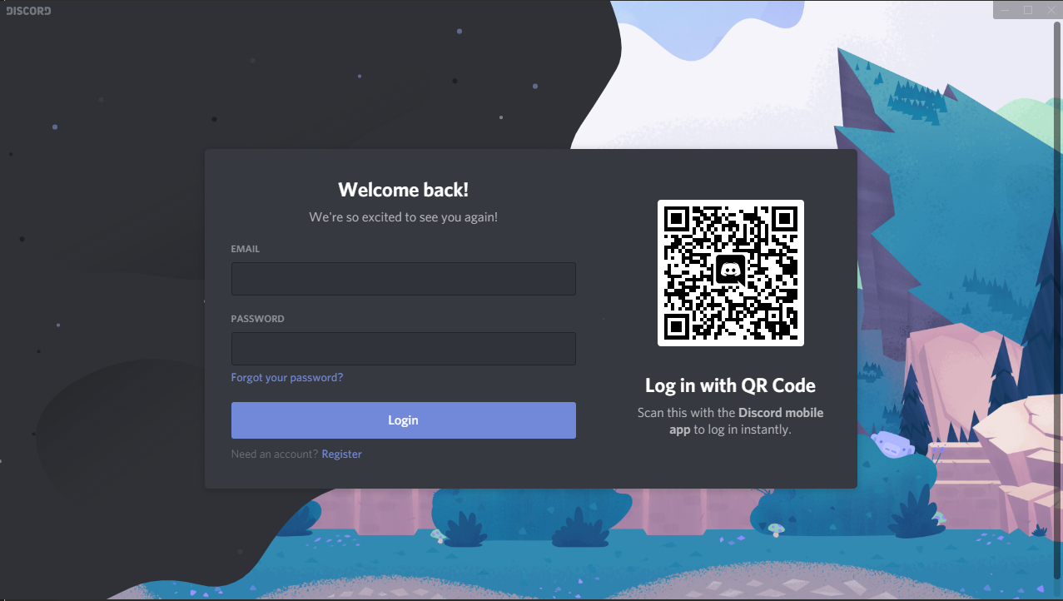

1. Join “Mr. Gudmestad’s Virtual Classroom Server”
   1. Once logged in, click the button and select Join a server
   2. Paste the URL <https://discord.gg/fj7KAsk> and click Join
2. If you’re using an alias for your name such as a gamer tag, change your nickname in “Mr. Gudmestad’s Virtual Classroom Server”
   1. Use your First and Last Name as your Nickname
   2. Right Click the Server Icon and select Change Nickname

# 

# Install Notepad++ , Git, and TortoiseGit

1. Download the 64-bit Notepad++ Installer from **(highly recommend using an adblocker to hide multiple fake download ads):** <https://chrome.google.com/webstore/detail/adblock-plus-free-ad-bloc/cfhdojbkjhnklbpkdaibdccddilifddb>

<https://notepad-plus-plus.org/download/>

1. Install Notepad++ with all the default settings.
2. Download the Git SCM installer from: <https://git-scm.com/>
3. Start the installer and follow the directions below:
   1. If prompted to create a global ignore file, **then do create one.**
   2. Select Notepad++ as the default editor
   3. Enable file system caching and the Git Credential Manager

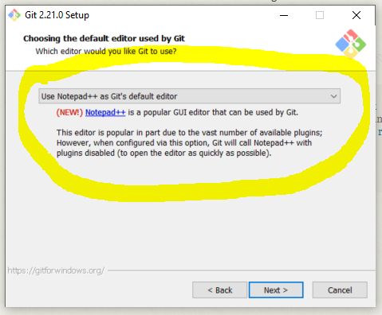

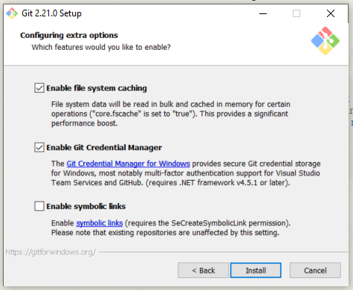

1. Download the 64-bit TortoiseGit Installer from: <https://tortoisegit.org/>
2. Install TortoiseGit using the default settings.
   1. When prompted for the location of Git, it should automatically locate your Git SCM install folder.
   2. When prompted for your name and email address, use your real name and school email (firstname_lastname@insideranken.org).
3. Now that you have Git and TortoiseGit installed, we need to make some small configuration changes.
   1. Right-Click your desktop and select **TortoiseGit > Settings**
   2. Select **Git,** verify that your Name is your real name, and verify that your Email is your school email.

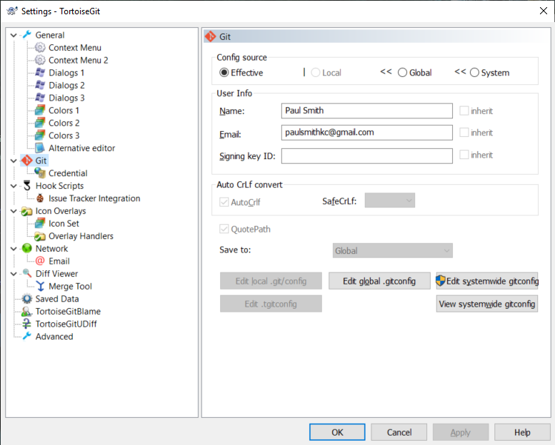

* 1. Select **Git Credential >> Open settings** and set the credential helper to **"manager - all Windows users"**

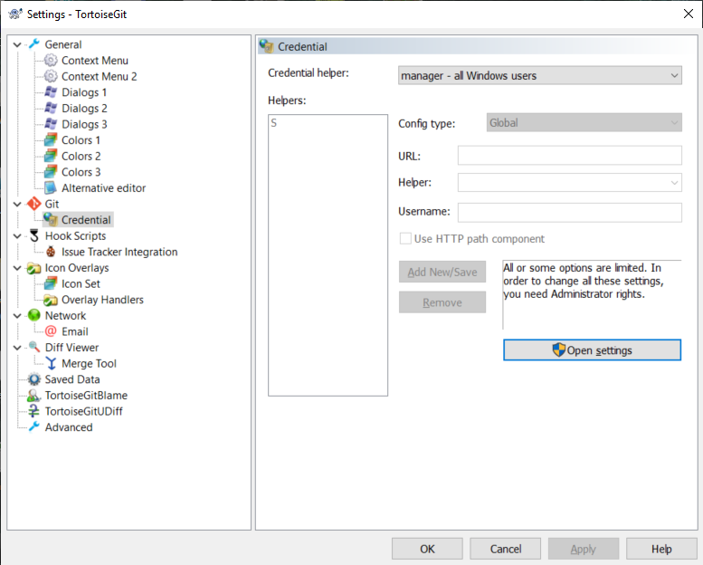

# 

# 

# 

# 

# 

# 

# Installing Visual Studio Community

1. Download Visual Studio Community from: <https://visualstudio.microsoft.com/vs/community/>
2. Install Visual Studio Community
   1. Select “.NET desktop development” when prompted with Workload options

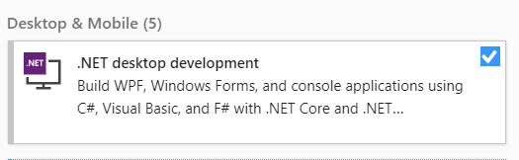

# 

# Install Balsamiq

1. Download **Balsamiq Wireframes for Desktop** from: <https://balsamiq.com/wireframes/desktop/>
2. Install Balsamiq with default settings.
3. Use the following academic license for Balsamiq:

**Product: Wireframes for Desktop**

**License Key: Ranken2020|GYjTeJxzCncxiQ+pCUrMy07NUzAyMDKoMTQztjC2sLAwAAEAnhEInQ==**

**License End Date: Dec 31, 2021**

[**https://balsamiq.com/wireframes/desktop/docs/intro/**](https://balsamiq.com/wireframes/desktop/docs/intro/)

# 

# 

# Register at GitHub Classroom and create your GitHub Repository

* Follow the link [**https://classroom.github.com/a/VRT3_y-S**](https://classroom.github.com/a/VRT3_y-S) and create a GitHub account with your username following a ***firstname_lastname*** syntax.
* You can add a number to your username if needed.
* Do not use a gamertag or other online alias for your username
* Once an account has been created and you’re logged in, **follow the link again** and select your name from the list provided.
* Click through the process of creating your online repository. It will look similar (although not exact) to this when finished

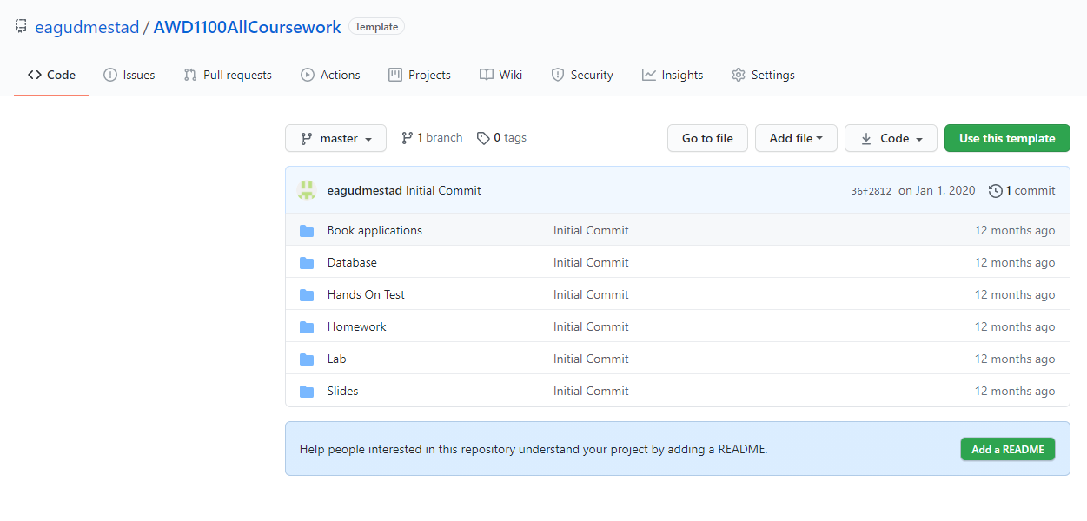

# 

# 

# 

# Clone your GitHub (online) Repository to a folder on your computer (local repository)

* You will need to decide where to place a folder (local repository) containing all your school work for the remainder of the semester
  + Some common options are your Desktop or My Documents
* When viewing your GitHub Repository, click the green Code button and copy the URL provided

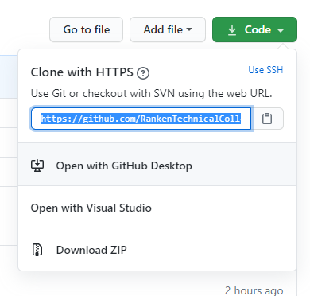

* Right click in the location where you want to put your local repository (possibly on your desktop) and select Git Clone. Click Ok. Provide your GitHub password if necessary. You should get a “success” message when the Clone has completed.

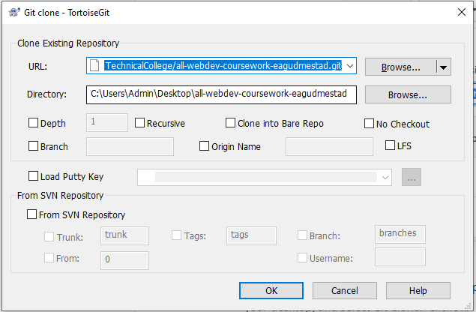

# 

# Install IOGear USB 3.0 Docking Station Drivers

# 

1. Download and install Driver/Software from: <https://www.iogear.com/support/dm/driver/GUD300>

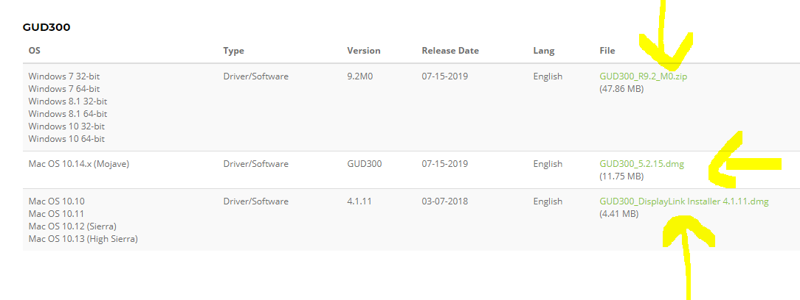

1. Choose **one** of the three files pictured above to download depending on your laptop’s Operating System